Case study 2:

Flipkart developers can deploy applications using a simple FlipkartApplication resource. However, they also want Kubernetes to automatically create an HPA (Horizontal Pod Autoscaler) whenever an application is deployed. The DevOps team will enhance the Operator so that it automatically creates both a Deployment and an HPA from a single custom resource.

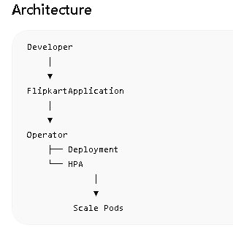
Step 1: Update CRD
Add:
minReplicas:
type: integer
maxReplicas:
type: integer
Now CRD becomes:
spec:
image:
replicas:
minReplicas:
maxReplicas:
Use : https://github.com/letslearn207/kubernetes/blob/main/c13/flipkart-crd1.yaml
Step 2: Create Resource
nano flipkartapp1.yml
Open https://github.com/letslearn207/kubernetes/blob/main/c13/flipkart-app1.yml and check
## RERUN THE KOPF PROCESS
ps -ef | grep kopf
Copy the pid
kill -9 12345
replace 12345 with actual pid
update flipkart_operator.py with:
import kopf
from kubernetes import client, config

config.load_kube_config()

@kopf.on.create('flipkart.com', 'v1', 'flipkartapplications')
def create_app(spec, name, namespace, **kwargs):

image = spec.get('image', 'nginx')
replicas = spec.get('replicas', 1)
min_replicas = spec.get('minReplicas', 1)
max_replicas = spec.get('maxReplicas', 5)

apps_api = client.AppsV1Api()
autoscaling_api = client.AutoscalingV2Api()

deployment = {
"apiVersion": "apps/v1",
"kind": "Deployment",
"metadata": {
"name": name
},
"spec": {
"replicas": replicas,
"selector": {
"matchLabels": {
"app": name
}
},
"template": {
"metadata": {
"labels": {
"app": name
}
},
"spec": {
"containers": [
{
"name": "app",
"image": image
}
]
}
}
}
}

apps_api.create_namespaced_deployment(
namespace=namespace,
body=deployment
)

hpa = {
"apiVersion": "autoscaling/v2",
"kind": "HorizontalPodAutoscaler",
"metadata": {
"name": f"{name}-hpa"
},
"spec": {
"scaleTargetRef": {
"apiVersion": "apps/v1",
"kind": "Deployment",
"name": name
},
"minReplicas": min_replicas,
"maxReplicas": max_replicas,
"metrics": [
{
"type": "Resource",
"resource": {
"name": "cpu",
"target": {
"type": "Utilization",
"averageUtilization": 50
}
}
}
]
}
}

autoscaling_api.create_namespaced_horizontal_pod_autoscaler(
namespace=namespace,
body=hpa
)

print(f"Deployment and HPA created for {name}")
Activate venv if needed:
source /root/operator-lab/venv/bin/activate
Go to your directory:
cd /home/ubuntu
Run:
kopf run flipkart_operator.py
You should see:
Initial authentication has been initiated.
Initial authentication has finished.
kubectl delete flipkartapplication payment-service
kubectl apply -f flipkartapp1.yml
kubectl get deploy
kubectl get hpa
kubectl get pods

